*Thứ Hai, 2 tháng 10, 2017*

**Cài cacti trên centos 6 tự động trong 1 nốt nhạc**

Cacti là một ứng dụng monitor hệ thống khá tốt với một số tính năng độc đáo.  
Bài viết này hướng đẫn cách cài đặt cacti lên centos 6 chỉ với 1 cú enter.  
Bắt đầu thôi

[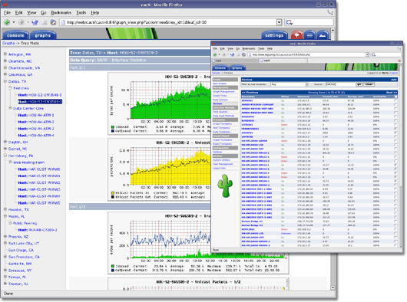](https://2.bp.blogspot.com/-qGfeLbbTkLQ/WdJ_dAXmvuI/AAAAAAAAAj8/jMhtjbbnvJUWQ5PpGTWpTnSMZBYkcsQGgCLcBGAs/s1600/cacti_promo_main.png)

**1. Chuẩn bị server**

Server: Centos 6.x bản 64bit  
Ram: 512mb trở lên  
HDD: 8GB trở lên.  
  
Note: script cài được cho bản 32 bit, tuy nhiên 1 số plugin 32 bit hiện không tìm thấy nữa :) nên nếu sử dụng 32bit thì chấp nhận thiếu hụt vài tính năng.

**2. Cài đặt.**

Tạo file **/root/cacti_install.sh** với nội dung sau:  
  
# !/bin/sh  
# Author: sanbangtatca022015@gmail.com  
# Script for install cacti 0.8.8c, spine 0.8.8c and various plugins on Centos Linux Release 6.x  
# Version : 1.2  
# Date : 24-4-2015  
  
# Tam thoi tat firewall  
chkconfig iptables off  
service iptables stop  
  
# Tat SELINUX  
sed -i 's/SELINUX=enforcing/SELINUX=disabled/g' /etc/selinux/config  
/usr/sbin/setenforce 0  
  
# Update Server  
yum update -y  
yum install -y wget  
mkdir -p /usr/src/cacti  
cd /usr/src/cacti  
  
# Cai dat apache & Mysql  
yum install -y httpd  
chkconfig httpd on  
service httpd start  
yum install -y mysql-server  
chkconfig mysqld on  
service mysqld start  
mysqladmin -u root password fn@1314  
yum install -y php php-gd php-mysql php-cli php-ldap php-snmp php-mbstring php-mcrypt   
service httpd restart  
  
# Cai dat rrdtool & snmp  
yum install -y rrdtool perl-rrdtool   
yum install -y net-snmp-utils   
yum install -y tftp-server  
chkconfig xinetd on  
service xinetd start  
  
# Download va cai dat cacti  
wget http://www.cacti.net/downloads/cacti-0.8.8c.tar.gz  
tar zxvf cacti-0.8.8c.tar.gz  
# Neu phien ban cacti dinh cai co then ban va loi thi tai ve va patch.  
# wget http://www.cacti.net/downloads/patches/0.8.8a/snmpv3_priv_proto_none.patch  
#cd cacti-0.8.8a  
yum install -y patch  
#patch -p1 -N < ../snmpv3_priv_proto_none.patch  
#cd ..  
mkdir /var/www/html/cacti/  
mv -f cacti-0.8.8c/* /var/www/html/cacti  
rm -rf cacti-0.8.8c  
chown -R apache:apache /var/www/html/cacti  
service httpd restart  
mysql -u root -pfn@1314 -e 'CREATE DATABASE `cacti` DEFAULT CHARACTER SET utf8 COLLATE utf8_general_ci;'  
mysql -u root -pfn@1314 -e "CREATE USER 'cactiuser'@'localhost' IDENTIFIED BY 'cactiuser';"  
mysql -u root -pfn@1314 -e 'GRANT ALL PRIVILEGES ON `cacti` . * TO 'cactiuser'@'localhost';'  
mysql -u cactiuser -pcactiuser cacti < /var/www/html/cacti/cacti.sql  
cat > /etc/cron.d/cacti <<EOF  
*/5 * * * * apache /usr/bin/php /var/www/html/cacti/poller.php > /dev/null 2>&1  
EOF  
# cai dat trinh bien dich ma nguon C++ & cai dat Spine  
yum install -y gcc gcc-c++ make automake patch libtool net-snmp-devel openssl-devel mysql mysql-devel rsyslog-mysql  
wget http://www.cacti.net/downloads/spine/cacti-spine-0.8.8c.tar.gz  
tar zxvf cacti-spine-0.8.8c.tar.gz  
cd cacti-spine-0.8.8c  
./configure   
make && make install  
cp /usr/local/spine/etc/spine.conf.dist  /usr/local/spine/etc/spine.conf  
cd /usr/src/cacti  
#------------------------------------------------------#  
# cai dat plugins  
  
wget http://docs.cacti.net/_media/plugin:settings-v0.71-1.tgz -O settings.tgz  
tar zxvf settings*.tgz -C /var/www/html/cacti/plugins  
chown -R apache:apache /var/www/html/cacti/plugins/settings  
wget http://docs.cacti.net/_media/plugin:clog-v1.7-1.tgz -O clog.tgz   
tar zxvf clog*.tgz -C /var/www/html/cacti/plugins  
chown -R apache:apache /var/www/html/cacti/plugins/clog  
wget http://docs.cacti.net/_media/plugin:thold-v0.4.9-3.tgz -O thold.tgz   
tar zxvf thold*.tgz -C /var/www/html/cacti/plugins  
chown -R apache:apache /var/www/html/cacti/plugins/thold  
wget http://docs.cacti.net/_media/plugin:monitor-v1.3-1.tgz -O monitor.tgz  
tar zxvf monitor*.tgz -C /var/www/html/cacti/plugins  
chown -R apache:apache /var/www/html/cacti/plugins/monitor  
wget http://docs.cacti.net/_media/plugin:realtime-v0.5-2.tgz -O realtime.tgz  
tar zxvf realtime*.tgz -C /var/www/html/cacti/plugins  
mkdir -p /var/www/html/cacti/plugins/realtime/cache  
chown -R apache:apache /var/www/html/cacti/plugins/realtime  
yum install -y unzip  
wget http://www.network-weathermap.com/files/php-weathermap-0.97a.zip  
unzip php-weathermap-0.97a.zip -d /var/www/html/cacti/plugins/  
chown -R apache:apache /var/www/html/cacti/plugins/weathermap  
wget http://docs.cacti.net/_media/plugin:mactrack-v2.9-1.tgz -O mactrack.tgz  
tar zxvf mactrack*.tgz -C /var/www/html/cacti/plugins   
chown -R apache:apache /var/www/html/cacti/plugins/mactrack  
wget http://docs.cacti.net/_media/plugin:syslog-v1.22-2.tgz -O syslog.tgz  
tar zxvf syslog*.tgz -C /var/www/html/cacti/plugins  
chown -R apache:apache /var/www/html/cacti/plugins/syslog  
wget http://docs.cacti.net/_media/plugin:routerconfigs-v0.3-1.tgz -O routerconfigs.tgz   
tar zxvf routerconfigs*.tgz -C /var/www/html/cacti/plugins   
mkdir -p /var/www/html/cacti/plugins/routerconfigs/backups  
chown -R apache:apache /var/www/html/cacti/plugins/routerconfigs  
wget http://docs.cacti.net/_media/plugin:docs-v0.4-1.tgz -O docs.tgz  
tar zxvf docs*.tgz -C /var/www/html/cacti/plugins   
mv -f /var/www/html/plugins/docs* /var/www/html/cacti/plugins/docs  
chown -R apache:apache /var/www/html/cacti/plugins/docs  
wget http://nchc.dl.sourceforge.net/project/cacti-reportit/cacti-reportit/reportit_v073/reportit_v073.tar.gz -O reportit.tar.gz  
tar zxvf reportit*.tar.gz -C /var/www/html/cacti/plugins   
chown -R apache:apache /var/www/html/cacti/plugins/reportit  
wget http://docs.cacti.net/_media/plugin:rrdclean-v0.41.tgz -O rrdclean.tgz   
tar zxvf rrdclean*.tgz -C /var/www/html/cacti/plugins  
chown -R apache:apache /var/www/html/cacti/plugins/rrdclean  
wget http://docs.cacti.net/_media/plugin:discovery-v1.5-1.tgz -O discovery.tgz  
tar zxvf discovery*.tgz -C /var/www/html/cacti/plugins  
chown -R apache:apache /var/www/html/cacti/plugins/discovery  
if [ "$HOSTTYPE" == "x86_64" ]; then  
wget http://www6.atomicorp.com/channels/atomic/centos/6/x86_64/RPMS/wmi-1.3.14-2.el6.art.x86_64.rpm  
rpm -Uvh wmi-1.3.14-2.el6.art.x86_64.rpm  
elif [ "$HOSTTYPE" == "i386" ]; then  
wget http://www6.atomicorp.com/channels/atomic/centos/6/i386/RPMS/wmi-1.3.14-2.el6.art.i686.rpm  
rpm -Uvh wmi-1.3.14-2.el6.art.i686.rpm  
fi  
wget https://github.com/neclimdul/CactiWMI/blob/master/wmi.php -O /var/www/html/cacti/scripts/wmi.php  
chown -R apache:apache /var/www/html/cacti/scripts/wmi.php  
service httpd restart  
  
Cuối cùng chạy lệnh:

# sh cacti_install.sh

Pha 1 tách cafe rồi ngồi đợi thôi :)

**3. Cấu hình cacti:**

Sau khi cài đặt xong, truy cập vào địa chỉ : http://IP_server/cacti

Tài khoản mặc định: admin password admin

Bấm Ok để lưu cấu hình.

Vào setting/poller

[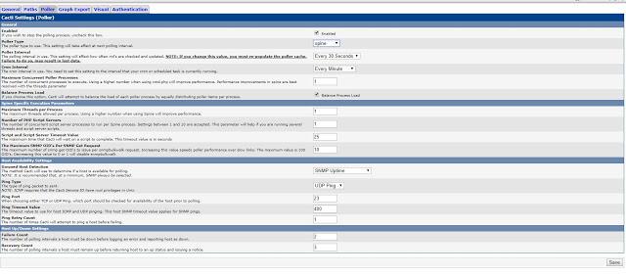](https://2.bp.blogspot.com/-M9Pj-z7r0Xc/WdJ-w4ttS4I/AAAAAAAAAj0/ME76oeJYX6EYzS5fHIipHc7_0EKqsSPjwCLcBGAs/s1600/poller.JPG)

Chọn poller là spin rồi ấn save

Vậy là xong

Các bước add host vào cacti các bạn tự google nhé :)